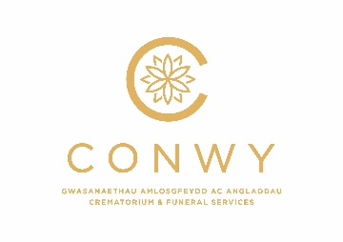
CREMATORIUM FEES

Cremation Services
CREMATIONS | 2022 FEES
Unattended Serviceª (Available between 8.15am and 8.45am only) | £467
Low-cost Service^{b} (Available between 9.00am and 9.30am only) | £586
Attended Service^{c} (18 years of age and over) | £773
Committal Service^{d} (Available at 12.30pm and 1.30pm) | £773
Committal Service (Available at 3.30pm) | £929
Stillborn baby/child under 18 years old (see Attended Service for details) | No Charge
Non-Viable Foetus (NVF) (Includes 30 minute use of the Cemetery Chapel) | No Charge
Retained Organs^{e} (Cremation only. Excludes chapel service) | £156
Double time slot additional fee | £295
Storage of Ashes after 1 month | £50

Tributes
Music | 2022 FEES
Obitus music system NEW FEE | £10
Hire of Organ | No Charge
Photos
Single Photo | £12
Simple Slideshow (up to 25 photos) | £65
Additional Photos (up to 50 photos) | £35
Professional Slideshow | £90
Keepsakes
DVD / USB / CD of Service | £60
Webcast Service | £50
Webcast & 28 days watch again Service | £70

Containers
ITEMS | 2022 FEES
Ashes Transit Box (Included in the cost of the cremation) | No Charge
Polytainer | £21
Wooden Casket | £62
Wicker Casket | £62
Bronze Urn | £44
Scattering Tubes | £21

Scattering
In Rose Garden, Meadow or Woodland Walk (Llanrhos) | 2022 FEES
Non witness scatter if cremated at Colwyn Bay | £ FOC
Witnessed scatter if Cremated at Colwyn Bay Crematorium | £40
If Cremated at another Crematorium | £170
NEW SERVICE
Scattering under turf on grave | £90

a Unattended Service includes cremation, medical referee fee, environmental surcharge, ashes transit box..
b Low cost Service includes use of the chapel (30 minutes to include entrance and exit, cremation, medical referee fee, environmental surcharge, ashes transit box..
c Attended Service includes use of the chapel (45 minutes to include entrance and exit, cremation, medical referee fee, environmental surcharge, ashes transit box..
d Committal Service includes use of the chapel (30 minutes to include entrance and exit, cremation, medical referee fee, environmental surcharge, ashes transit box..
e Retained Organs includes cremation, medical referee fee, environmental surcharge, ashes transit box..

